

OpenL Tablets Installation Guide

OpenL Tablets 5.10.1
OpenL Tablets BRMS

Document number: OpenL_Inst_G_5.x_1.0
Revised: 04-15-2013

OpenL Tablets Documentation is licensed under a Creative Commons Attribution 3.0 United States License.
Contents
Preface 4
How This Book Is Organized 4
Audience 4
Related Information 5
Typographic Conventions 5
Chapter 1: Before You Begin 6
Chapter 2: Install OpenL Tablets WebStudio under Apache Tomcat 7
Step 1: Installing the JDK 7
Step 2: Installing Apache Tomcat 8
How to Install Apache Tomcat on Windows 8
How to Install Apache Tomcat on Unix / Linux Machine 10
Step 3: Deploying OpenL Tablets WebStudio 11
Step 4: Setting Up OpenL Tablets Web Studio with Installation Wizard 13
OpenL Tablets WebStudio Customization 13
Configuring External User Database 14
Configuring User Mode 15
Chapter 3: Install OpenL Tablets WebStudio on WAS 16
Chapter 4: Install OpenL Tablets under Eclipse 17
Step 1: Installing Eclipse SDK 17
Step 2: Installing OpenL Tablets under Eclipse 18
Remote Installation of OpenL Tablets Eclipse Plugin 19
Installation of OpenL Tablets Eclipse Plugin from Zip File 20
Step 3: Run OpenL Tablets WebStudio 21
Chapter 5: Deploy OpenL Tablets Web Services 28
Chapter 6: OpenL Tablets WebStudio and Web Services Integration 30
Troubleshooting Notes 32
FAQs 33

Preface
OpenL Tablets is a Business Rules Management System (BRMS) based on tables presented in Excel documents. Using unique concepts, OpenL Tablets facilitates treating business documents containing business logic specifications as executable source code.
OpenL Tablets provides a set of tools addressing BRMS related capabilities including OpenL Tablets WebStudio that can be used for creating, testing and managing business rules and business rule projects, and OpenL Tablets Web Services designed for integration of business rules into customer’s applications.
The OpenL Tablets Installation Guide provides instructions for installing and customizing OpenL Tablets software. The document describes how to install OpenL Tablets under Apache Tomcat and as Eclipse plugin. If you choose the last way of installation, you will be able to use a set of tutorials and examples designed to help you better understand OpenL Tablets features and functionality. Information on how to deploy and setup OpenL Web Services is provided as well.

How This Book Is Organized
Chapter 1 lists system requirements for installing and using OpenL Tablets software.
Chapter 2 explains how to install OpenL Tablets WebStudio under Apache Tomcat.
Chapter 3 describes the installation of OpenL Tablets WebStudio under Eclipse.
Chapter 4 is designed for developers and describes how to deploy OpenL Tablets Web Services.
Chapter 5 explains how to setup OpenL Tablets WebStudio and Web Services as an integrated environment.
FAQs and Troubleshooting Notes sections provide useful information related to OpenL Tablets installation.

Audience
This guide is mainly targeted at business users and rule experts who will define, view, and manage their business rules and rule projects via OpenL Tablets WebStudio. Developers will also use this document to learn how to install and setup OpenL Web Services.
Basic knowledge of Java, Eclipse, and Apache Tomcat is required to use this guide effectively.

Related Information
The following table lists sources of information related to contents of this guide:
Related information
Title | Description
OpenL Tablets WebStudio User Guide | Document describing OpenL WebStudio, a web application for managing OpenL Tablets projects through web browser.
OpenL Tablets Reference Guide | Provides overview of OpenL Tablets technology, as well as its basic concepts and principles.
http://openl-tablets.sourceforge.net/ | OpenL Tablets open source project website.

Typographic Conventions
The following styles and conventions are used in this guide:
Typographic styles and conventions
Convention | Description
Bold | Represents user interface items such as check boxes, command buttons, dialog boxes, drop-down list values, field names, menu commands, menus, option buttons, perspectives, tabs, tooltip labels, tree elements, views, and windows.  Represents keys, such as F9 or CTRL+A.  Represents a term the first time it is defined.
Courier | Represents file and directory names, code, system messages, and command-line commands.
Courier Bold | Represents emphasized text in code.
Select File > Save As | Represents a command to perform, such as opening the File menu and selecting Save As.
Italic | Represents any information to be entered in a field.  Represents documentation titles.
< > | Represents placeholder values to be substituted with user specific values.
Hyperlink | Represents a hyperlink. Clicking a hyperlink displays the information topic or external source.

Chapter 1: Before You Begin
This chapter covers system requirements for installing and running OpenL Tablets software provided in the following table.

Software requirements
Operating systems | Microsoft Windows XP (SP2 or higher), Vista, Windows 7 x32/64; Ubuntu 12.x; Linux 3.x.  NOTE: OpenL Tablets software can potentially run on any Operating System that supports Java Virtual Machine, e.g. Mac OS. In this table we only provide operating systems on which the OpenL Tablets software is tested and supported.
Browsers | Microsoft Internet Explorer 9.x or later, Firefox 17.x or later, Chrome 23.x or later.
Other Software | - Java v6 x32/64 - JDK 1.6.0_x or later  - Apache Tomcat 7.0.x or later  - Eclipse 3.6 or later  NOTE: Instructions on how to install and configure these software packages are provided further in this document.
Hardware requirements
- RAM 2 Gb min (4 Gb is recommended)
- 1 GHz or faster 32-bit (x86) or 64-bit (x64) processor
User rights requirements
 | - You must have administrative permissions to install the software under Microsoft Windows / UNIX system.

NOTE: We highly recommend you to avoid using spaces and special characters in paths.

Chapter 2: Install OpenL Tablets WebStudio under Apache Tomcat
This chapter first describes how to setup an environment for working with OpenL Tablets software; then we move to deploy OpenL Tablets WebStudio under Apache Tomcat, and also provide information about settings required for proper functioning of the application.
Follow these steps:
Step 1: Install Java Development Kit (JDK).
Step 2: Install Apache Tomcat
Step 3: Deploy OpenL Tablets WebStudio
Step 4: Set up OpenL Tablets WebStudio with the Installation Wizard

Step 1: Installing the JDK
Follow the steps below to install the JDK.
- Download JDK 1.6.0_x or later from http://www.oracle.com/technetwork/java/javase/downloads/index.html to the target directory. Further in the document this catalog is referred as <JAVA_HOME>.
NOTE: We highly recommend you to avoid installing Java in the default Program Files directory because it may cause some problems due to space characters in the path to the folder.
- Refer to http://www.oracle.com/technetwork/java/javase/index-137561.html for installation details if required.
- Install the JDK according to the instructions.
- Set the environment variable JAVA_HOME to the pathname of the directory where the JDK is installed as follows:
- For Microsoft Windows:
- Open the System Properties dialog: press <Windows> + <Pause> hotkey or right-click the My Computer icon and select Properties in the pop-up menu.
- On the Advanced tab, click the Environment Variables button.
- In the System variables area, click the New button
- Enter JAVA_HOME in the Variable name field.
- Enter the path to the directory where the JDK is installed in the Variable value field, for example, C:\Java\jdk1.6.0_20.
- Click OK to complete.
- For Unix/Linux environments (let’s assume that the target directory is /usr/lib/jvm/java-6-sun):
To set up JAVA_HOME for a single user:
- Login to your account and open .bash_profile:
nano ~/.bash_profile
- Add the following line:
export JAVA_HOME=/usr/lib/jvm/java-6-sun
- Add/correct system PATH
export PATH=$PATH:$JAVA_HOME/bin
- Press CTRL+O to save your work, and then press CTRL+X to exit.
To set up JAVA_HOME for all users:
- Login as root and open /etc/profile:
nano /etc/profile
- Add the following line
export JAVA_HOME=/usr/lib/jvm/java-6-sun
- Add/correct system PATH
export PATH=$PATH:$JAVA_HOME/bin

Step 2: Installing Apache Tomcat
You can install Apache Tomcat from zip file or using Windows Service Installer.

How to Install Apache Tomcat on Windows

From Zip File
Follow the steps below to install Apache Tomcat 7.0.x (or later):
- Open Apache Tomcat home page at http://tomcat.apache.org/index.html.
- In the left-hand Download menu, click the latest available Tomcat version.
- Locate the Binary Distributions area; in the Core list click on the zip file corresponding to your Windows version.
- Save the zip file in a temporary directory.
- Unpack downloaded zip into target folder on your computer. This folder is referred as <TOMCAT_HOME> further in this document.
- Configure JVM options for Tomcat web server as follows:
- For Windows, create TOMCAT_HOME/bin/setenv.bat file and write:
set JAVA_OPTS=%JAVA_OPTS% -Xms256m -Xmx1024m -XX:+UseParallelOldGC -XX:PermSize=128m -XX:MaxPermSize=384m

How to Install Apache Tomcat Using Windows Service Installer
This section describes how to install Apache Tomcat using Windows Service Installer.
NOTE: We don’t recommend you to select this type of installation if you are planning to edit your rule tables in Excel files from OpenL Tablets WebStudio (See the Modifying Tables section in OpenL Tablets WebStudio User Guide) because some additional settings are required for that. Please contact your OpenL Tablets administrator to solve the issue.
NOTE: For OpenL Tablets administrator. To allow editing rule tables in Excel files from OpenL Tablets WebStudio, please enable the Allow service to interact with desktop Tomcat service option using MMC or from the command line.
- Navigate to Apache Tomcat site at http://tomcat.apache.org/index.html.
- In the left-hand Download menu, click the latest available Tomcat version.
- Locate the Binary Distributions area; in the Core list click the 32-bit/64-bit Windows Service Installer link.
- Save the apache-tomcat exe file in a temporary folder.
- Run the exe file and follow the instructions of the installation wizard. Click Next to move to the next step or return to the previous step by clicking the Back button.
- In the License Agreement window, click I Agree.
- In the Choose Components dialog, leave the default Normal type of installation. If you are an experienced Tomcat user you can also select another installation type from drop-down list.
- In the Configuration dialog, leave the settings at their default values.
- In the next window the Wizard displays the folder where Tomcat will be installed – the Destination Folder. This folder is referred as <TOMCAT_HOME> further in this document.
- Click Install to start the installation.
- Click Finish to complete.
As a result, Apache Tomcat is installed and started on your computer. In the Notification Area (next to the clock) the icon appears. You can manage Tomcat by using this icon or from the Start menu.
- Configure JVM options for Tomcat. For that right click the Apache Tomcat icon in the Notification area and select Configure; or click start->All Programs->Apache Tomcat 7.0-> Configure Tomcat. The Apache Tomcat Properties dialog appears.
- Click the Java tab and add in the Java Options text box (every option should be manually entered in a separate row):
-Xms256m
-Xmx1024m
-XX:+UseParallelOldGC
-XX:PermSize=128m
-XX:MaxPermSize=384m
NOTE: You can add that settings using the Copy/Paste feature; just make sure there are no spaces in the end of every row.
- Click Apply and then click OK.
- Restart Tomcat: right click the Tomcat icon in the Notification Area and select Stop service (the Tomcat icon changes to) and then select Start Service again. You can also restart Tomcat from the General tab in the Apache Tomcat Properties dialog which appears after selecting start->All Programs->Apache Tomcat 7.0-> Configure Tomcat.
From this point you can run OpenL Tablets WebStudio as described in Step 3.

How to Install Apache Tomcat on UNIX / Linux Machine

Installing Apache Tomcat from Repository
Note! All commands should be entered into a terminal window using an account with sudo privileges.
This section describes how to install Apache Tomcat from repository as a service on Ubuntu 12.x.
- Open a terminal window and enter the following:
sudo apt-get install tomcat7
- Start Tomcat with the next command:
sudo /etc/init.d/tomcat7 start
All necessary folders should be located in /var/lib/tomcat7.
- To ensure that Tomcat works properly, open your browser and enter http://localhost:8080.
If all is correct, you will see Apache Tomcat welcome page with a message similar to the following:
“If you're seeing this, you've successfully installed Tomcat. Congratulations!”
In case 404 Error appears, try to restart Tomcat:
sudo /etc/init.d/tomcat7 restart
Or you can stop Tomcat by entering the next command:
sudo /etc/init.d/tomcat7 stop
Start Tomcat again as described above.

Installing Apache Tomcat from zip File
This section describes how to install Apache Tomcat on Ubuntu 12.04 and Centos 6.3. The instructions are valid for other Linux distributions with some small changes.
- Download the appropriate Tomcat archive file from its official website: http://tomcat.apache.org/download-70.cgi (zip or tar.gz archive) to your user folder. In our example, we use Tomcat 7.0.39 and download it to the following folder:
/home/myuser
- Open a terminal window and change directory to the folder containing the Tomcat archive.
- Extract the archive by entering in the terminal the following command (you can change tomcat version as required):
tar -zxvf apache-tomcat-7.0.39.tar.gz
The apache-tomcat-7.0.39 folder appears; for our example:
/home/myuser/apache-tomcat-7.0.39
- Change directory to the tomcat/bin:
cd apache-tomcat-7.0.39/bin
- Make sure all *.sh files are executable, i.e. they have r in all positions to the left of the file name, for example, -rwxr-xr-x. For that, enter in terminal the following:
ls –la
You should see something like this:
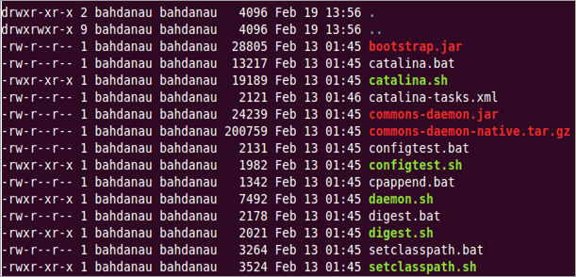
Figure 1: OpenL Tablets package is added to Eclipse
- If some sh files aren’t executable, enter the following command:
chmod +x ./*.sh
- Run the sturtup.sh file:
sh ./startup.sh
- In your browser, enter the following URL: http://localhost:8080
If the installation completed successfully, you will see the Apache Tomcat welcome screen. The next thing to be done is to configure JVM options for Tomcat.

Configure JVM options for Tomcat on UNIX / Linux Machine
- For UNIX, create TOMCAT_HOME/bin/setenv.sh file and write
export JAVA_OPTS="$JAVA_OPTS -Xms256m -Xmx1024m -XX:+UseParallelOldGC -XX:PermSize=128m -XX:MaxPermSize=384m"
- Locate the TOMCAT_HOME/conf/server.xml file and add the URIEncoding="UTF-8" attribute for all <Connector> elements. For example:
<Connector port="8080" protocol="HTTP/1.1" connectionTimeout="20000" redirectPort="8443" URIEncoding="UTF-8"/>
From this point you can deploy OpenL Tablets WebStudio as described in the next step.

Step 3: Deploying OpenL Tablets WebStudio

On a Windows Machine
This section describes how to deploy and run OpenL Tablets WebStudio under Tomcat on a Windows machine.
- Go to http://openl-tablets.sourceforge.net/downloads page.
- Click the appropriate WebStudio (war) link.
- Save the file in a temporary folder.
- Copy the WebStudio war file (for example, openl-tablets-webstudio-X.X.X.war) to the <TOMCAT_HOME>\webapps folder.
- Run Tomcat.
- If you have installed Tomcat from ZIP file you should click the startup.bat file in TOMCAT_HOME\bin.
- If Tomcat is installed using Windows Service Installer, restart Tomcat as described in Step 2, paragraph 13.
Tomcat will unpack the war file into the <TOMCAT_HOME>\webapps\<war file name> folder. For example, for 5.9.4 version the target folder can be <TOMCAT_HOME>\webapps\openl-tablets-webstudio-5.9.4. For convenience, you can rename the folder as you need but please remember that you will use this name to launch WebStudio under Tomcat.
From this point on, you can run OpenL Tablets WebStudio with default settings or make additional customizations: change User Mode and/or configure an external User Database as described in the OpenL Tablets WebStudio Customization section.
- Run OpenL Tablets WebStudio by entering in your browser the following URL: http://localhost:8080/<war file name>. I.e. for our example you should enter http://localhost:8080/openl-tablets-webstudio-5.9.4.
OpenLTablets WebStudio opens in your browser on the Welcome to Installation Wizard page. The wizard will guide you through the setup process as described in Step 4. After the setup process is complete you can work in the OpenLTablets WebStudio — create new projects or download existing ones.
NOTE: After you have installed a new release of the WebStudio, click CTRL+F5 to reload the page in your browser.

On a Linux Machine
Follow the steps below to install OpenL Tablets WebStudio under Linux.
- Create the <OPENl_HOME> folder where the application will be deployed as follows:
sudo mkdir /<OPENl_HOME>
- Change access rights for this folder:
sudo chmod 775 -R /<OPENl_HOME>
- Change the owner for this folder:
sudo chown tomcat7:tomcat7 /<OPENl_HOME>
- Download OpenL WebStudio war file from http://sourceforge.net/projects/openl-tablets/files/openl-tablets/ to a temporary folder.
- Copy the downloaded war file to your Tomcat webapps folder:
cp /home/myuser/Downloads/<openl-tablets-webstudio-xxxx.war>/home/myuser/<TOMCAT_HOME>/webapps/webstudio.war
- Stop Tomcat — run the following command from /home/myuser/<TOMCAT_HOME>/bin :
sh shutdown.sh
- Start Tomcat from the same folder:
sh startup.sh
- In your browser enter http://localhost:8080/webstudio
In case the deployment succeeded without any errors, the OpenL Tablets Web Studio Installation Wizard described in the next step opens in your browser.
If you encounter any problems, open the following log files for details: home/myuser/<TOMCAT_HOME>/logs/catalina.out and home/myuser//<TOMCAT_HOME>/logs/webstudio.log

Step 4: Setting Up OpenL Tablets Web Studio with Installation Wizard
This topic describes the steps you should take after the first run of OpenL Tablets WebStudio under Tomcat. You can accept the default options provided by the Wizard. For that, just click Next to move to the next step; or you can change the options as you need and then click Next to proceed.
All steps are accompanied by detailed explanations that help you choose the right option.
- Click the Start button in the Welcome to OpenL Tablets WebStudio Installation Wizard page.
- In the next screen, specify a working directory for OpenL Tablets. This folder is referred as <OPENL_HOME> in the documentation. (We highly recommend you not to use the system drive for that.) Click Next to proceed.
- Select a user mode:
- Single-user — Only the user currently logged on to the computer can work with the WebStudio (refer to OpenL Tablets WebStudio User Guide for details);
- Multi-user — Multiple users can run the WebStudio with their unique names.
- For the Multi-user mode, in the Select application mode area specify the database for users management:
- Demo — The default database which contains a predefined list of users and does not require additional settings;
- Production — An external MySQL database with a customizable list of users.
- If you have selected the Production mode, the Configure database area appears with the following database parameters:
- Database URL — By default, localhost:3306/openl should be used;
- Username / Password — Enter your username and password that you have specified for MySQL database. (See the Configuring External User Database section further in this guide.)
- Click the Finish button to complete.
As a result, the logging screen appears where you should enter your credentials to start working with OpenL Tablets WebStudio.

OpenL Tablets WebStudio Customization
This section provides information on what additional configurations can be made for OpenL Tablets WebStudio and how to make them.

Configuring External User Database
By default, OpenL Tablets WebStudio runs using an internal User Database (User DB) based on the HSQLDB database engine. It is a good idea to use the internal User DB for demonstration purposes because it is provided by default and requires no additional setup. But in this case all user management changes will be lost after server restart.
In a production environment, we strongly recommend using an external database. This section explains how to set up a MySQL database to be used for managing users in OpenL Tablets WebStudio.
Follow the steps below to configure external MySQL database.
- Go to http://dev.mysql.com/downloads/mysql/.
- Select the appropriate MSI Installer for your system configuration and click Download. For example, you may need Windows (x86, 32-bit), MSI Installer. We don’t recommend you to use ZIP Archive version since it’s intended for advanced users.
- In the next screen you will be prompted to register or login on MySQL site. You can skip this step and proceed to No thanks, just start my download! link.
- Select Save File in the next dialog and save the .msi file in a target folder.
- Navigate to the folder containing the .msi file and double click on the file to start the installation process. The MYSQL Server Setup Wizard Welcome screen of appears.
- Follow the steps the Wizard takes you through leaving the defaults and clicking Next.
- Click Finish to close the Wizard when installation is complete.
NOTE: It is recommended to configure your database server to use UTF-8 character set.
After MySQL is successfully installed on your computer, create an empty database for WebStudio in MySQL and grant permissions to modify this database to the user from which the WebStudio will work with this database.
For that:
- Open MySQL Command Line Client as follows: start -> All Programs -> MySQL -> MySQL Server 5.5 -> MySQL Command Line Client.
- Type the following commands:
CREATE USER openl_user IDENTIFIED BY 'openl_password';
CREATE DATABASE openl CHARACTER SET utf8;
GRANT ALL PRIVILEGES ON openl.* TO openl_user;
Now you should set up the User DB properties:
- Open the <OPENL_HOME>/syskmtem-settings/ folder or create this folder if it does not exist yet.
- Create the db.properties file in this folder and specify the required settings:
db.hibernate.dialect = org.hibernate.dialect.MySQLDialect
db.driver = com.mysql.jdbc.Driver
db.url = jdbc:mysql://<host>/<database name>
db.user = <user>
db.password = <password>
Here is an example of the configuration you can use for your User Database:
db.hibernate.dialect = org.hibernate.dialect.MySQLDialect
db.driver = com.mysql.jdbc.Driver
db.url = jdbc:mysql://localhost:3306/openl
db.user = openl_user
db.password = openl_password
When you have made all the additional configurations, you should run OpenL Tablets WebStudio as described in the Deploying OpenL Tablets WebStudio step, point 6.
From here, i.e. after your set up your User DB and successfully run WebStudio you may want to make sure that the external User DB works properly. For that, run MySQL Command Line Client and enter the following command:
select loginname from openl.openluser;
As a result, you should see a list of users existing in OpenL Tablets WebStudio.

Configuring User Mode
This topic explains how to change user mode to be used in OpenL Tablets WebStudio. For more information on user modes please refer to the ‘Security Overview’ section in OpenL Tablets WebStudio User Guide.
By default, user mode is set to ‘Single’. If you need to change it, you should select the Multi-user option in OpenL Tablets WebStudio Installation Wizard. You can also change user mode as a JVM option for Tomcat. For that, open the Apache Tomcat Properties dialog (see point 12 in the How to Install Apache Tomcat Using Windows Service Installer section) and add in the Java Options text box:
-Duser.mode=multi
NOTE: User mode set as a Java option takes precedence over the corresponding value specified in the OpenL Tablets WebStudio Installation Wizard. So if both of them are defined the Java option value will be used.

Chapter 3: Install OpenL Tablets WebStudio on WAS
This section explains how to install OpenL Tablets WebStudio on WebSphere Application Server (hereafter referred as WAS).

Prerequisites
The following tasks must be completed prior to deploying OpenL Tablets WebStudio on WAS.
IBM WebSphere Application Server v. 8.5 or later should be installed on your local machine, or you need access to a WAS instance with logon that has appropriate permissions to configure JVM options. For information on how to install IBM WebSphere Application Server visit Oracle Online documentation, section Installing and Configuring WebSphere 8.5 section on http://docs.oracle.com/cd/E24902_01/doc.91/e23435/inst_config_was85_win.htm
IMPORTANT! When defining the Shared Resource Directory during the installation process, the path to the directory should be specified without spaces. Otherwise, OpenL Tablets WebStudio will fail.
Follow the steps below to deploy OpenL Tablets WebStudio on WAS.

Step 1: Set up JVM options for WAS
- In the WebSphere Application Server Console, navigate to Servers/ServerTypes/WebSphere Application Servers. You will see your server in the right pane.
- In the right pane, click your sever name; by default it is server1.
- Locate the Server Infrastructure area and expand the Java Process Management node.
- Click Process Definition.
- Click the Java Virtual Machine link on the upper right.
- In the Initial heap size text box, enter 256.
- In the Maximum heap size text box, enter 1024.
- In the Generic JVM Arguments add the following string
-XX:+UseParallelOldGC -XX:PermSize=128m -XX:MaxPermSize=384M -Dclient.encoding.override=UTF-8
- Click OK.
- In the Message dialog which appears in the top of the form, click the Save directly to the master configuration item to save your work.
- Restart your WebSphere Application Server.

Step 2: Prepare OpenL Tablets WebStudio WAR File
- Go to http://openl-tablets.sourceforge.net/downloads page.
- Click the appropriate WebStudio (war) link.
- Save the file in a temporary folder.
- Open the downloaded war file as a zip archive.
- From the \WEB-INF\lib\ folder, remove the following jar files:
validation-api-1.0.0.GA.jar
xercesImpl-2.8.1.jar
xml-apis-1.3.03.jar
- Save the war file.

Step 3: Deploy OpenL Tablets WebStudio on WAS
- Enter in your browser the following URL https://localhost:9043/ibm/console (this is default port for local installation). The WebSphere Application Server Console opens.
- Navigate to Applications / Application Types / WebSphere enterprise applications
- Click the Install button in the top line tool bar.
- In the Path to the new application area, select your modified WebStudio war file (the Local file system option is selected by default).
- Click the Next button to proceed until you get to Step 2: Map modules to servers.
- In the Step 2: Map modules to servers page, select the checkbox on the left of the file name and click Next to proceed.
- In the Step 3: Map virtual hosts for Web modules page, select the checkbox on the left of the file name and click Next to proceed.
- In the Step 4: Map context roots for Web modules page, enter in the Context Root text field /webstudio and click Next to proceed.
- Click the Finish button in the bottom of the screen to complete. After the installation process complete, clock the Manage Applications link.
- In the next screen, click on the webstudio war file link in the list of applications.
- In the next screen, locate the Default Properties area and click the Class loading and update detection link.
- In the next screen, select the following radio-buttons: Classes loaded with local class loader first (parent last) and Single class loader for application.
- Click OK to finish.
- In the next window, again click the Save directly to the master configuration link.
Now the OpenL Tablets WebStudio application is installed and started (if no, start the application).
- Run OpenL Tablets WebStudio by entering http://localhost:9080/webstudio/ in your browser. The Welcome to OpenL Tablets WebStudio Installation Wizard page appears allowing you to set up the application as needed. Refer to the Setting Up OpenL Tablets Web Studio with Installation Wizard section for details.

Chapter 4: Install OpenL Tablets under Eclipse
This chapter provides information on how to install OpenL Tablets under Eclipse. You will also learn how to run OpenL Tablets WebStudio under Eclipse.
The installation process consists of the following steps:
Step 1: Install Eclipse SDK.
Step 2: Install and setup OpenL Tablets Wes Studio as Eclipse Plugin.
Step 3: Run OpenL Tablets WebStudio.
NOTE: If you have JDK and Eclipse SDK installed and properly set up on your computer, please skip Step 1 and Step 2.
Prerequisites
- The JDK 1.6.0_x (or later) is correctly installed.
- An environment variable JAVA_HOME is set to the pathname of the directory where the JDK is installed. For more information on how to set up JAVA_HOME see Installing the JDK.

Step 1: Installing Eclipse SDK
- Download Eclipse from http://www.eclipse.org/downloads/ to the target directory.
NOTE: We recommend you to install the Eclipse Classic package.
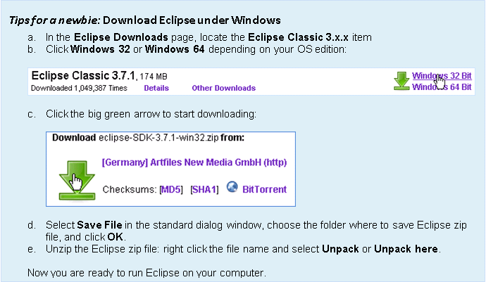
- Navigate to the Eclipse folder and click eclipse.exe to run Eclipse. The Workspace Launcher dialog appears.
- In the Workspace Launcher dialog, specify your Eclipse workspace - the folder where your will save all OpenL Tablets projects. We recommend you to define the workspace as follows: \<OPENL_HOME>\user-workspace, where <OPENL_HOME> is the openl folder in the root directory of the non-system disk.
NOTE: Please don’t use the C:\Documents and Settings\ folder that can be shown in the dialog by default. We highly recommend that you don’t select the system drive; and the path should not contain spaces. For example, your workspace folder can be \openl\user-workspace.
As a result, the Welcome to Eclipse window appears. From this point you can install OpenL Tablets under Eclipse as described in Step 2.

Step 2: Installing OpenL Tablets under Eclipse
You can install OpenL Tablets Eclipse Plugin in one of the following ways:
- Remotely from the Sourceforge.net site
- From a Zip file
IMPORTANT! If you have OpenL Tablets already installed in Eclipse, you should first remove previously configured settings, uninstall OpenL Tablets, and perform the installation as described below.
You can remove the existing settings in one of the following ways.
- Delete the \<OPENL_HOME>\ folder. In this case, all rule projects saved in your workspace will be removed as well.
- If you want to save your rule projects, proceed as follows:
- Locate your workspace folder, for example, \<OPENL_HOME>\user-workspace.
- Delete the folders: .metadata, logs, org.openl.rules.webstudio.
- Open the \<OPENL_HOME>\system-settings folder and delete the system.properties file.
To uninstall Eclipse SDK:
- Run Eclipse SDK.
- Select Help > About Eclipse SDK > Installation Details.
- Locate OpenL Tablets for Eclipse.
- Select it and click the Uninstall button.
- Click Finish to complete and select Restart Now to restart Eclipse.
If you have any problems with uninstalling OpenL Tablets, please delete the existing Eclipse directory, unzip Eclipse zip file, and install a clear Eclipse as described in Step 2.

Remote Installation of OpenL Tablets Eclipse Plugin
Follow the steps below to install the OpenL Tablets Eclipse Plugin remotely:
- Run Eclipse SDK.
- In the top line menu, select Help > Install New Software. The Install dialog appears.
- In the Work with text box, enter the URL: http://openl-tablets.sourceforge.net/eclipse-site/ and press Enter.
- Click the Select All button to select all items:
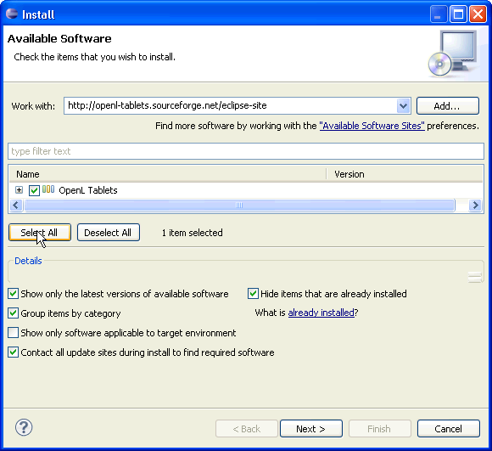
Figure 2: Remote installation of OpenL Tablets under Eclipse
- In the Details area, clear the Contact all update sites during install to find required software checkbox.
- Press the Next button and follow the installation steps:
- Click the Next button in the Install Details window
- Select I accept option in the Review Licenses dialog to accept license agreements.
- Click Finish to complete. If the Security Warning dialog appears, click OK to proceed.
- After the installation is complete, you will be prompted to restart Eclipse SDK. Click the Restart Now button.

Installation of OpenL Tablets Eclipse Plugin from Zip File
- Download the Eclipse Update Site zip file as follows:
- Open the OpenL Sourceforge Project page
- Click the openl-tablets link:
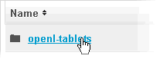
Figure 3: Move to OpenL Tablets
- In the Name column, navigate to the latest OpenL Tablets version and click its name. For example, for version 5.9.4 you will click the OpenL Tablets 5.9.4 link.
- Locate the openl-tablets-eclipse-site-<version>.zip file. For the version 5.8.1 you should click the following link:
Figure 4: Select ZIP file
- Click the zip file name and save it in a target folder.
- Run Eclipse SDK.
- In the top line menu, select Help > Install New Software.
- Press the Add button.
- Type OpenL Tablets in the Name field.
- Press the Archive button. The Repository archive dialog appears.
- Locate the downloaded zip file and click the Open button.
- Click OK to proceed.
- Click the Select All button to select all items.
- In the Details area, clear the Contact all update sites during install to find required software checkbox.
- Press the Next button.
- Follow the installation dialog windows to download and install OpenL Tablets for Eclipse.
- Click OK in the Security Warning dialog.
- To Restart Eclipse, click the Restart Now button in the prompted dialog.
RESULT: The Java – Eclipse SDK window appears. From this point, you can launch OpenL Tablets WebStudio as described in the next step.

Step 3: Run OpenL Tablets WebStudio
You should first add OpenL Tablets WebStudio to Eclipse as a new project and then launch it.
- Add OpenL Tablets to Eclipse as a new project
- From the top line menu, select File > New > Project.
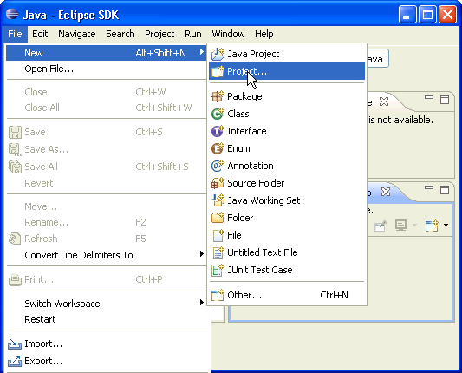

Figure 5: Add a new project in Eclipse
The New Project window appears.
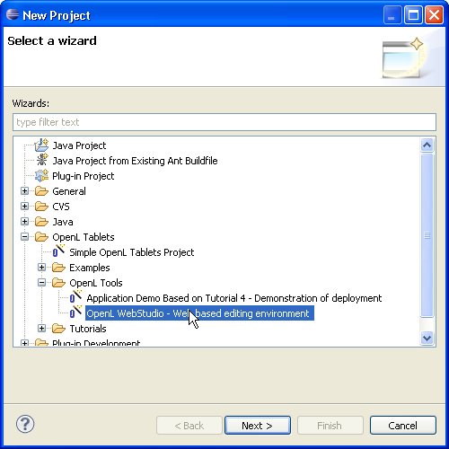
Figure 6: Select OpenL Tablets WebStudio as a new project
- In the tree, expand OpenL Tablets > OpenL Tools and select the OpenL WebStudio – Web based editing environment item.
- Click Next to proceed.
- In the following window, define where your projects will be located: select the Use default location or specify the desired one.
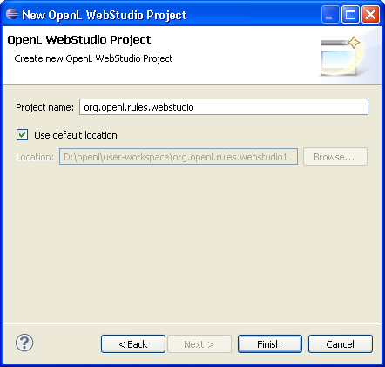
Figure 7: Define workspace for OpenL Tablets projects
NOTE: Please remember to use paths without spaces or special characters.
- Click Finish to complete.
RESULT: The org.openl.rules.webstudio item appears in the Package Explorer as illustrated in the Figure below.
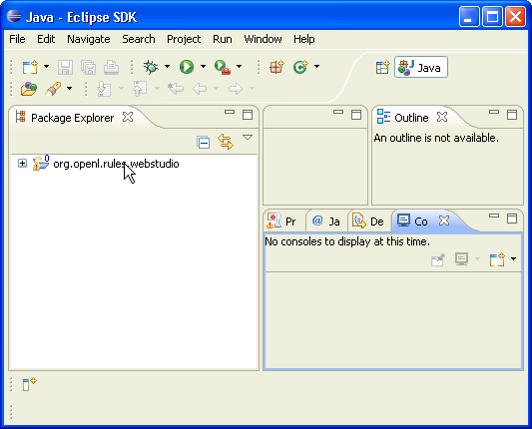
Figure 8: OpenL Tablets package is added to Eclipse
- Run OpenL Tablets WebStudio:
- Expand the org.openl.rules.webstudio node.
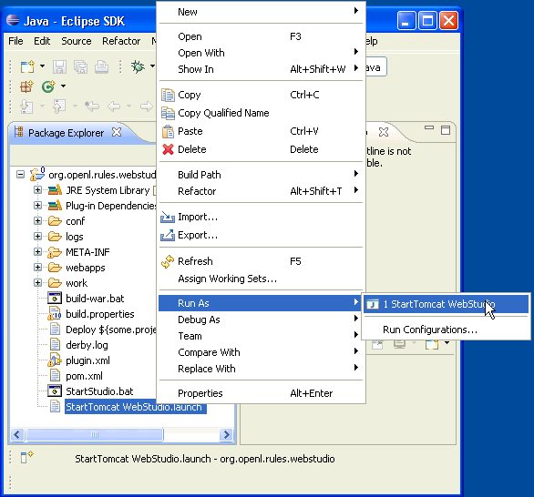
Figure 9: Run OpenL Tablets WebStudio in Eclipse
- Right-click the StartTomcat WebStudio.launch item and select Run as > StartTomcat WebStudio in the pop-up menu.
RESULT: OpenL Tablets WebStudio opens in the default browser.
NOTE: After you have installed new release of the WebStudio, click CTRL+F5 to reload the page in your browser.
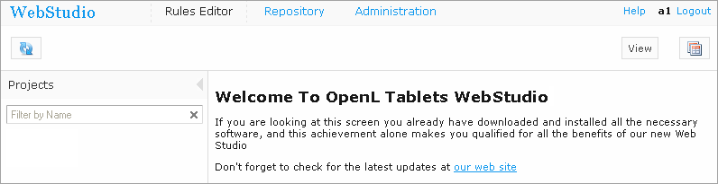
Figure 10: OpenL Tablets WebStudio is open and ready for use
NOTE: OpenL Tablets Eclipse plugin provides several tutorials and example projects. To work with any of these projects, first you need to create them as new projects in the Eclipse SDK. The procedure is similar to described in Step 3: Run OpenL Tablets WebStudio. After that the projects are available in OpenL Tablets WebStudio and appear in the Projects list.

Chapter 5: Deploy OpenL Tablets Web Services
This chapter is designed for rule developers who will want to use business rules as separate web services.
NOTE: We will consider a particular case when you will use a file system as a data source for your projects. In such a case all OpenL Tablets projects should be placed into a local folder; this folder will represent a single deployment containing all the projects. In turn, every project should also be represented as a separate folder.
For more information on how to configure OpenL Tablets Web Services see the OpenL Tablets Web Services Usage and Customization guide.
Prerequisites
Make sure the following tasks have been performed:
- The JDK 1.6.0_x (or later) and Apache Tomcat 7.0.x (or later) is correctly installed.
- We will refer the folder where Tomcat is installed as <TOMCAT_HOME>.
- An environment variable JAVA_HOME is set to the pathname of the directory where the JDK is installed.
- JVM options should be set up as described in the Installing Apache Tomcat section.
The deployment process consists of the following steps:
- Download pre-configured OpenL Tablets Web Services application (war-file):
- Go to http://openl-tablets.sourceforge.net/downloads page.
- Click the appropriate Services Frontend (war) link.
- Save the chosen war file to the <TOMCAT_HOME>\webapps directory. For example, let’s assume we saved the openl-tablets-ws-5.9.4.war file.
- Configure a local file system as a data source as follows:
- Navigate to the <TOMCAT_HOME>\webapps folder and unzip the web services war file. For example, you can right-click the web services war file name and select 7-zip > Open archive.
- Open the WEB-INF\classes folders and locate the openl-ruleservice-datasource-beans.xml file.
- Right click the openl-ruleservice-datasource-beans.xml file and select Edit in the popup menu.
- Override the following beans as shown below:
<bean id="datasource" class="org.openl.rules.ruleservice.loader.FileSystemDataSource">
<constructor-arg name="loadDeploymentsFromDirectory" value="… path to the folder containing the projects"/>
<property name="localWorkspaceFileFilter" ref="localWorkspaceFileFilter"/>
<property name="localWorkspaceFolderFilter" ref="localWorkspaceFolderFilter"/>
</bean>
- Put your rule project to the /openl/datasource folder on the drive where you start Tomcat. Every rule project should be represented as a separate folder. As an example you can use OpenL Tablets Tutorial that you can download from the OpenL Tablets web site.
- Run Tomcat by clicking the startup.bat file in <TOMCAT_HOME>\bin.
To ensure the deployment is successful you can try the web service with a tool at your option.
NOTE: In the Tomcat log file you can find the URL that you should use to run your Web Service. For file system data source, the URL should look like http://localhost:8080/<ws war file name>/<datasource folder>/<rule project name>?wsdl, where <datasource folder>/<rule project name> can be taken from the Tomcat log file.

Chapter 6: OpenL Tablets WebStudio and Web Services Integration
Earlier in this document we discussed how to install OpenL Tablets WebStudio, and also how to properly deploy and configure OpenL Tablets Web Services.
This section describes how to setup an integrated environment that enables you to work with business rules from OpenL Tablets WebStudio and launch these rules as Web Services. Here we describe how to setup OpenL Tablets WebStudio and Web Services integration via RMI.
NOTE: In the given example OpenL Tablets WebStudio should run under Tomcat. As a repository we will use a common repository which you can download from OpenLTablets site, or request from OpenL Tablets team.
- If not done earlier, put and unzip jackrabbit and web services war files to the \<TOMCAT_HOME>\webapps. We recommend you to use the jackrabbit-webapp-2.2.8.war file (you can download it from http://repo1.maven.org/maven2/org/apache/jackrabbit/jackrabbit-webapp/2.2.8/jackrabbit-webapp-2.2.8.war).
NOTE: You should also add the jcr-2.0.jar file to the \<TOMCAT_HOME>\webapps\ jackrabbit-webapp-2.2.8\WEB-INF\lib. You can download this file from http://search.maven.org/remotecontent?filepath=javax/jcr/jcr/2.0/jcr-2.0.jar
- From OpenL Tablets site, download the common repository zip file containing your rule to any folder. This location will be later used as datasource. In our example we use \openl\ folder.
- Set up jackrabbit.zip:
- Download the jackrabbit.zip file from the OpenL Tablets web site (Currently the file is not accessible from this site. Please refer to OpenL Tablets team for the file). Unpack the file to the \<TOMCAT_HOME>\bin\jackrabbit folder (create the jackrabbit folder if it does not exist).
- Locate \<TOMCAT_HOME>\webapps\bin \jackrabbit\bootstrap.properties file. It should contain the following lines:
repository.config=jackrabbit/jackrabbit-repository.xml
repository.home=D:/openl/common-repository
repository.name=2TR
# RMI Settings
rmi.enabled=true
rmi.port=0
rmi.host=localhost
# If the URI is not specified, it's composed as follows:
#rmi.uri=//${rmi.host}:${rmi.port}/${repository.name}
rmi.url=//localhost:1099/2TR
- Set up Web Services as follows:
- Locate the \<TOMCAT_HOME>\webapps\<ws project name>\WEB-INF\classes\rules-production.properties file.
- Update the rules-production.properties file.
- Mark as comment these lines:
# production-repository.factory = org.openl.rules.repository.factories.LocalJackrabbitProductionRepositoryFactory

# production-repository.local.home=/openl/common-repository
- Remove the comment mark from these lines:
production-repository.factory = org.openl.rules.repository.factories.RmiJackrabbitProductionRepositoryFactory

production-repository.remote.rmi.url = //localhost:1099/2TR

- Set up OpenL Tablets WebStudio:
- Download and copy WebStudio war file to <TOMCAT_HOME>\webapps
- Locate <OPENL_HOME>\system-settings – if the folder does not exist, create it. Create system.properties file and store in this folder.
- Add properties
For Design repository:
design-repository.factory = org.openl.rules.repository.factories.RmiJackrabbitDesignRepositoryFactory

design-repository.remote.rmi.url = //localhost:1099/2TR

For Production repository:
production-repository.factory = org.openl.rules.repository.factories.RmiJackrabbitProductionRepositoryFactory

production-repository.remote.rmi.url = //localhost:1099/2TR
- Run WebStudio by entering in your browser http://localhost:8080/<WEbStudio war file name>.
As a result, OpenL Tablets WebStudio home page appears with your project deployed. From this point you can make any changes in your rule in WebStudio, these change will immediately affect your rule represented as Web Service.
NOTE: In the Tomcat log file you can find the URL that you should use to run your Web Service. The URL should look like http://localhost:8080/<ws war file name>/<deployment name>/<rule project name>?wsdl.

Troubleshooting Notes
If you deploy OpenL Tablets WebStudio under Tomcat in Unix/Linux environment, the following troubleshooting recommendations can be taken into account.
- Before starting tomcat under Linux make sure that no java processes are running:
sudo ps -A | grep j
If found, the process name and number will be displayed.
- If any Java process is running, stop it:
kill -9 <process number>
- Make sure that port 8080 is available:
sudo netstart –an | grep 8080
- Run Tomcat under Linux:
<TOMCAT_HOME>/bin/startup.sh
- If the 'command not found' error appears, you should mark .sh file as executable script:
chmod +x startup.sh
- If one of the errors 'Permission denied' or 'The BASEDIR environment variable is not defined correctly' is shown then make all .sh files in the bin folder executable:
chmod 777 *.sh
- Verify that all .sh files in the bin folder are executable:
ls –la
- Run Tomcat
<TOMCAT_HOME>/bin/startup.sh

FAQs
This section provides the most common questions and answer related to OpenL Tablets installation procedure. For detailed Information about working with Java, Eclipse, Tomcat, etc please refer to corresponding sites of the software manufacturers.
- Q: How can I check if Java is installed on my PC?
- R: You can do it as follows:
For Windows XP:
  - Open start > Control Panel
  - Double click Add or Remove Programs
For Windows 7/Vista:
- Open start > Control Panel
- Click Programs > Programs and Features
Look through the list for ‘Java(TM)…’ or ‘Java(TM) Update…’ items. If any of them are present then you have Java installed on your PC.
- Q: During Java installation the page for Java registration appears. Do I have to register Java?
- R: No, it is optional. You can just close the registration page.
- Q: How can I check which version of Java is installed on my PC?
- R: Open the Verify Java Version page and click the Verify Java Version button. In just a few seconds a new page appears where you will find the message similar to the following one: “Your Java version: Version 6 Update 26”.
- Q: How can I see the error message in the Tomcat console that appears when I start Tomcat? The error screen disappears too quickly.
4. R: Run catalina.bat run in the command line window as follows: click Start > Run, browse to <TOMCAT_HOME>\bin folder, select catalina.bat and add run in the command line.
5. Q: When I try to start OpenL Tablets WebStudio under Eclipse in the Linux OS, ‘404 error’ occurs.
5. R: Create the ‘openl’ folder in the root of the disk where Eclipse is installed with ‘write’ permission:
chmod 777 openl
To be sure the WebStudio will work properly, set the same permissions for the ‘Workspace’ folder.
- Q: When I try to run OpenL Tablets WebStudio in Eclipse, the following error message appears:
Error occurred during initialization of VM
Could not reserve enough space for object heap
- R: Restart your computer and try again.

